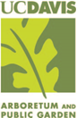
UC DAVIS ARBORETUM AND PUBLIC GARDEN
Learning by Leading Signature Project FALL 2018
Commitment: ~3-5 hours/week
FALL 2018

ABOUT
Work with professional Arboretum horticulturists, curatorial and museum education teams to develop your plant identification skills and practice field-surveying methods. Interns will develop project management, communication, and reporting skills essential for excelling in environmental and land management careers.
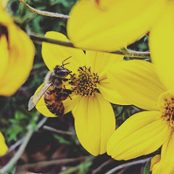
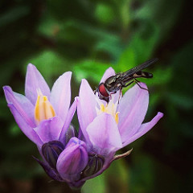
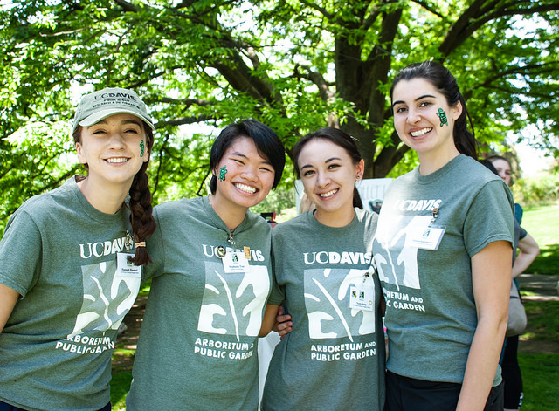

SIGNATURE PROJECT DESCRIPTION
Assist with surveying, mapping and data collection in the Arboretum. Use cartographic, horticultural, and technical skills to create a geographic inventory of the Arboretum’s research and teaching collection. Duties include project management, data entry and cartographic design. With assistance and training, identify both common and unusual plants by botanical name using existing maps and horticultural records. Participate in cross-functional projects and develop a Signature Project portfolio. Accepting two students Fall 2018.

If you are interested in learning more about our program before you apply, contact the Signature Project Mentor, Angelica Sauceda amsauceda@ucdavis.edu

UC DAVIS ARBORETUM AND PUBLIC GARDEN
SIGNATURE PROJECT APPLICATION Fall 2018

INSTRUCTIONS:
Please complete and e-mail your answers back to Angelica Sauceda (amsauceda@ucdavis.edu). Thoughtful responses are appreciated. Spaces are limited, so please apply as soon as possible.

Application Deadline: Friday, Sept 28 by midnight
Fall Quarter Meeting Time: Every Tuesday from 2 - 5 PM

Applying for:
UCD Arboretum & Public Garden Signature Project – send to Angelica Sauceda, amsauceda@ucdavis.edu
Please use this format for your email subject: First and last name – Signature Project Application

1. Name:

E-mail:

Phone:

Year at UC Davis:

Major:

2. Please list your Monday - Friday availability for the fall. Are you available to meet on Mondays from 1-4 PM during Fall Quarter?

3. Why are you interested in this internship? What do you want to learn or hope to gain?

4. Describe your interest or knowledge in plant identification.

5. Have you had prior leadership experience? Describe in detail please.

6. Have you had prior experience with survey tools and methods? Please describe.

7. Please list any classes you have taken or experiences you have had relating to identifying or cultivating plants. (Note: Experience with plant identification is not required, but will be helpful.)

8. Why should we choose you? What strengths will you bring to our team?

